NAAN MUDHALVAN ASSIGNMENT DOCUMENT

**COURSE TITLE** : DIGITAL MARKETING

**COLLEGE CODE** 1105

**COLLEGE NAME** : GOJAN SCHOOL OF BUSINESS AND TECHNOLOGY

**NM ID** : 036295D6FCADDF9BDC542A7D31A50A9C

**NAME** : KOUSIGA G

**REGISTER NUMBER** 110520106005

**YEAR** : 4TH YEAR

**DEPARTMENT** : ELECTRONICS AND COMMUNICATION ENGINEERING

1. Create a blog or website using Blogspot and Wordpress. Customize the theme design and post new article with 500 words.

Link: <https://musicophile0223.blogspot.com/2023/10/musico-phil.html>



1. Create a New Facebook Business Page and post one social media poster for your brand.

Link: [https://www.facebook.com/people/Musico-](https://www.facebook.com/people/Musico-Phile/pfbid02di5B4d1bND5uhmhDVAgWwC3mqBnhBmwym2FFyrRq6iDzgyqZpB576CRv16nH9ADGl/?mibextid=ZbWKwL) [Phile/pfbid02di5B4d1bND5uhmhDVAgWwC3mqBnhBmwym2FFyrRq6iDzgyqZpB576CRv](https://www.facebook.com/people/Musico-Phile/pfbid02di5B4d1bND5uhmhDVAgWwC3mqBnhBmwym2FFyrRq6iDzgyqZpB576CRv16nH9ADGl/?mibextid=ZbWKwL) [16nH9ADGl/?mibextid=ZbWKwL](https://www.facebook.com/people/Musico-Phile/pfbid02di5B4d1bND5uhmhDVAgWwC3mqBnhBmwym2FFyrRq6iDzgyqZpB576CRv16nH9ADGl/?mibextid=ZbWKwL)

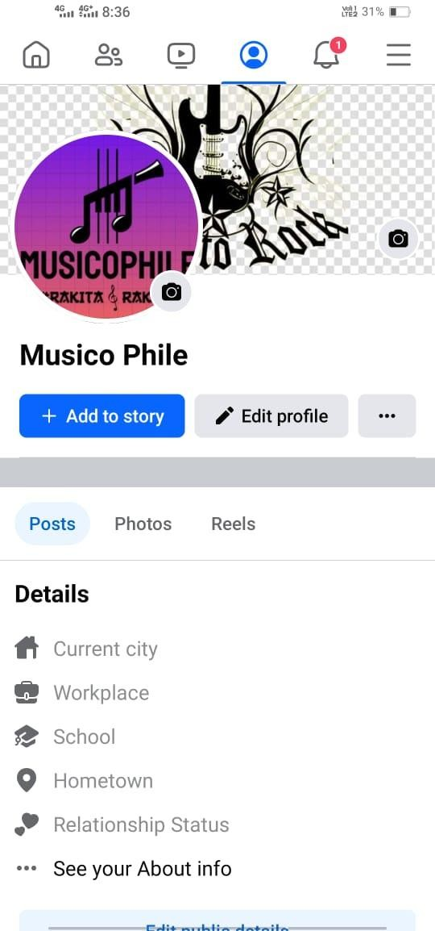

1. Create and design a social media advertisement poster using canva.



1. Create email newsletter design using MailChimp or canva tool.

Link: [https://www.canva.com/design/DAFx5qgoz-](https://www.canva.com/design/DAFx5qgoz-4/BD0kNIsKvAIBzbf0RrcnAA/view?utm_content=DAFx5qgoz-4&utm_campaign=designshare&utm_medium=link&utm_source=editor) [4/BD0kNIsKvAIBzbf0RrcnAA/view?utm_content=DAFx5qgoz-](https://www.canva.com/design/DAFx5qgoz-4/BD0kNIsKvAIBzbf0RrcnAA/view?utm_content=DAFx5qgoz-4&utm_campaign=designshare&utm_medium=link&utm_source=editor) [4&utm_campaign=designshare&utm_medium=link&utm_source=editor](https://www.canva.com/design/DAFx5qgoz-4/BD0kNIsKvAIBzbf0RrcnAA/view?utm_content=DAFx5qgoz-4&utm_campaign=designshare&utm_medium=link&utm_source=editor)

